User documentation

* **A high-level description.**

Minesweeping is like a mathematical reasoning problem. The fun of the game lies in thinking and reasoning. Of course, the biggest difference between minesweeping and other games should be "boring". Just like the joke of playing minesweeping in Internet cafes, because the original intention is not to entertain users, the production of minesweeping is very simple, and there is no card to look like a game. But I have to admit that mine sweeping has achieved what all games want to do but can't do, that is popularity. As long as there is windows on any computer, there is mine sweeping. To some extent, mine sweeping has the largest player group in the world.

However, only a small number of people really experienced mine sweeping, and most of them were discouraged by their complex mathematical reasoning. As the mathematician Gauss said, "some beautiful theorems in mathematics have such characteristics: they are easily summarized from facts, but the proof is very hidden." The rules of mine sweeping are very simple, and the playing method only requires a mouse click, but there are too few people who can settle down to experience this game.

* **How to install the software.**

Our minesweeping game does not need to be installed. We only need to download three folders and click the runnable file to run it。

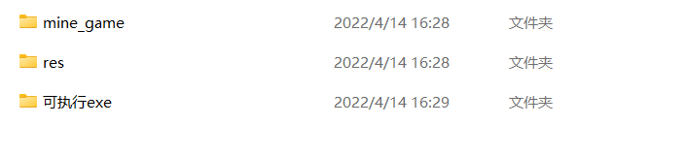

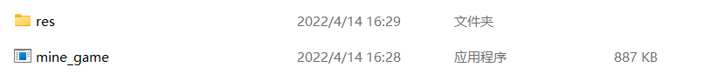

* **How to run the software.**



Click this mine_game to run.

* **How to use the software.**

Our game is developed based on windows, and subsequent versions will be upgraded on the original version.On how to use the click open file to play the game directly

* **How to report a bug.**

When developing our game, we conducted a lot of tests to eliminate bugs. If there are loopholes in the game later, we can report to the person in charge

* **Known bugs.**

Our known bugs and historical versions have been backed up and will be upgraded and iterated continuously